Student Name: __________________
Class and Section __________________
Total Points (10 pts) __________________
Due: October 22, 2010 before the class

Project: Moving the Ball

CSCI 1302 Advanced Programming Principles
Armstrong Atlantic State University

Problem Description:
Write a program that moves the ball in a panel. You should define a panel class for displaying the ball and provide the methods for moving the button left, right, up, and down, as shown in the following figure. Check the boundary to prevent the ball from moving out of sight completely.

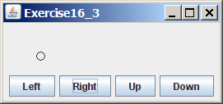

Design:
(Draw a sketch of UI)

Coding:
Name your main class Exercise15_03

Screen shots:

Submit the following items:

1. Submit a hard copy of this document.

2. Compile and Submit to LiveLab as Exercise16_03 (you must submit the program regardless whether it complete or incomplete, correct or incorrect)

3. Fill in self-evaluation:

- Is the UI created correctly? _____
- Is the circle displayed correctly? _____
- Is the circle moved in the right direction upon clicking a button? _____
- Does your program check the boundary to prevent the ball from moving out of sight completely? _____

